**TIH Divyasampark iHub Roorkee for Devices Material and Technology Foundation at IIT Roorkee (Technology Vertical: Device Technology and Materials):**

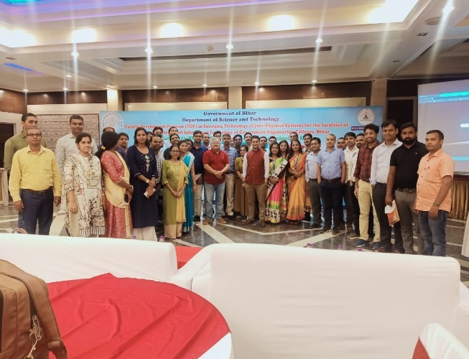**Skill Development program with DST Bihar government:**

iHUB DivyaSampark is running a large-scale training program to train 12,000 engineering colleges students of Bihar in CPS domain. Students are getting trained in topics like AI/ML, Data science, EV, Drones, Robots etc. iHUB DivyaSampark is also training some 300 professors from those engineering college under ‘train the trainer’ program so that they can guide and train many other students in the future.

**Our startup Ballice Smart Devices Pvt. Ltd. has developed a IoT enabled smart solar cooker and IOT enabled smart air purification**

In IOT based smart air purification, data is recorded in dashboard on which decisions are driven, information is projected via graph and stats whereas a solar based DC induction stove to provide solution to some remote/ resource prone areas where cooking is not possible.

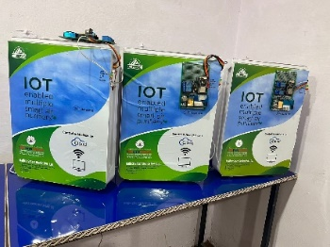

IoT enabled smart Air Purification

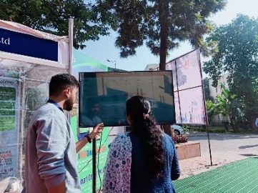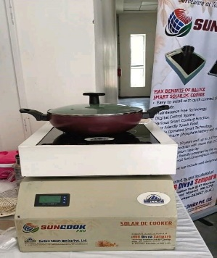

IoT based Solar Cooker

**Our startup Evigway Technologies Pvt. Ltd,** developed **SYENAH Software** – A GIS & AI enabled software for Border & Critical areas detailed surveillance. Selected as one of the Top 35 Startups in “Emerging Technologies” by the Ministry of Electronics & IT, Govt of India in “Digi-Week 2022”.

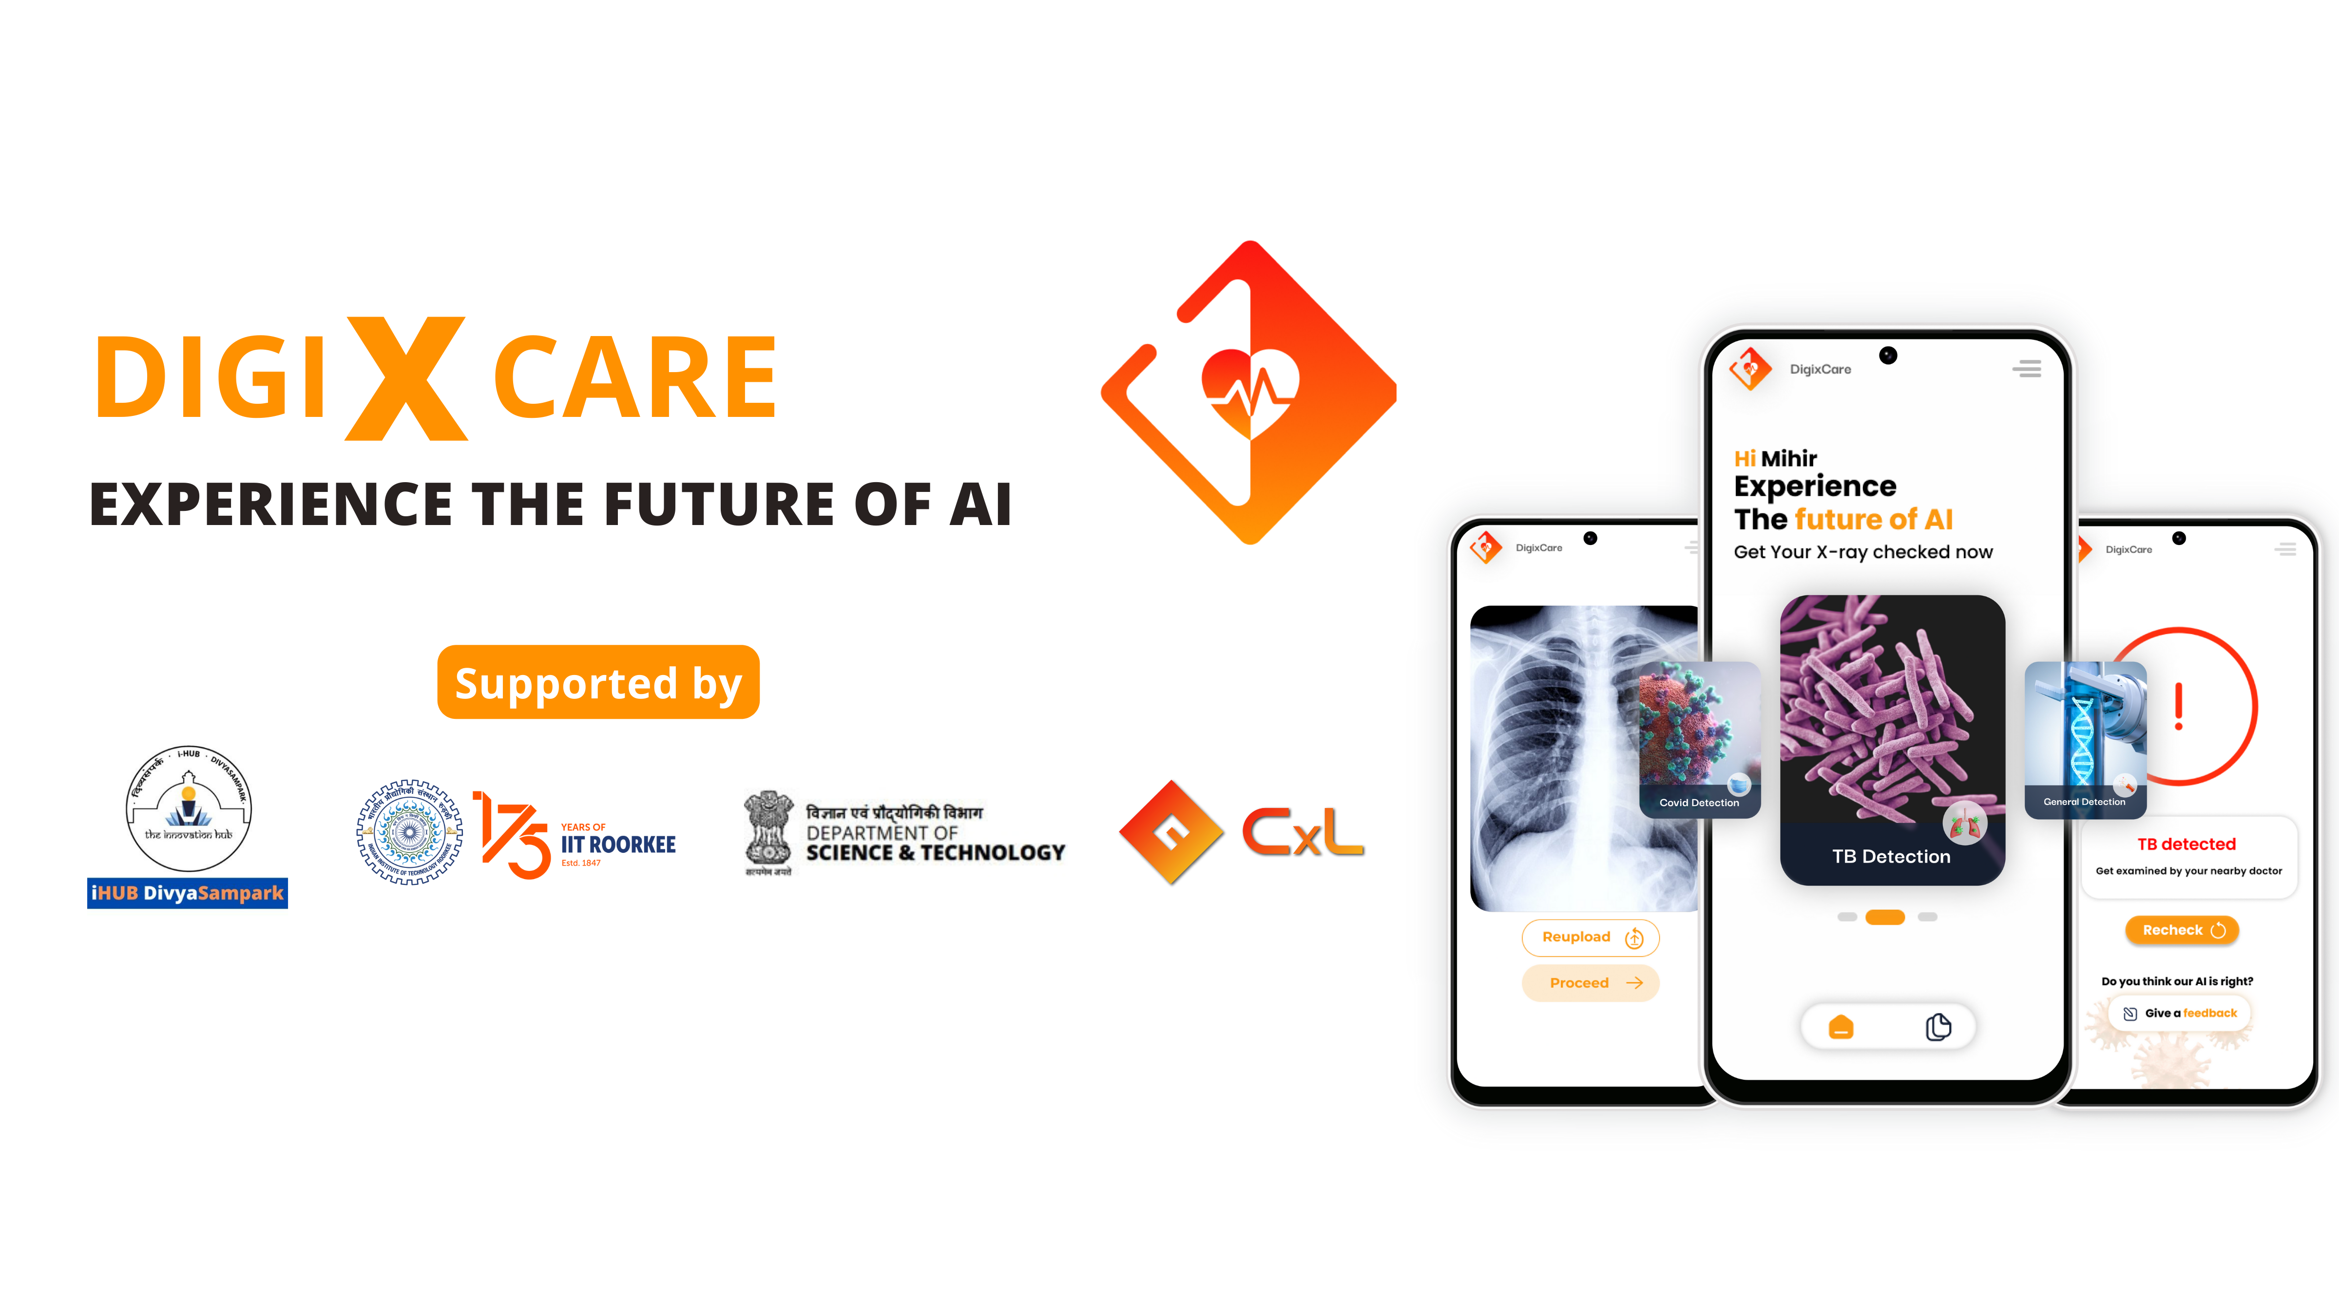

**iHUB DivyaSampark in association with CogXR Labs is announced a free app for experiencing the future of healthcare.**

DigiXCare, a mobile app to screen Covid, TB, Pneumonia, and much more, based on an X-ray image.

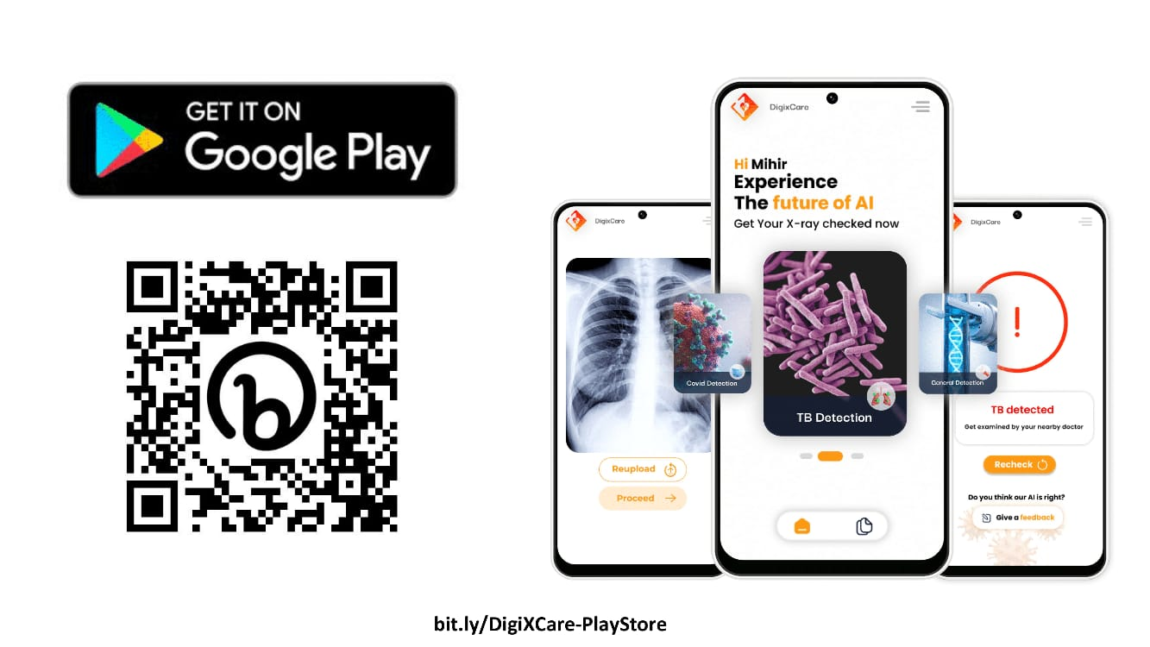

[Click Here to Download](https://play.google.com/store/apps/details?id=com.cogxrlabs.digixcare0)

**DIGIXCARE**

**By supporting deep tech startups, iHUB DivyaSampark aims to make a significant impact on our society through technology innovation:**

Our startup Dtown Robotics is a deep tech company working in the field of designing and fabricating robotics and drone solutions in the field of defence, agriculture and logistics. The application areas for the product includes reconnaissance, last mile delivery, perimeter security and tele-robotics, agriculture spraying and sowing. The fabrication of these drones target maximum indigenised content that we can bring to the product. Currently, the robots carry 90% indigenised parts and drones contain 65% indigenised parts.

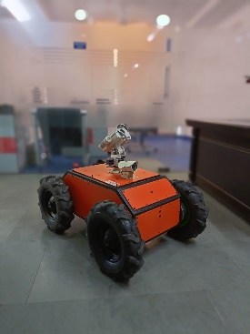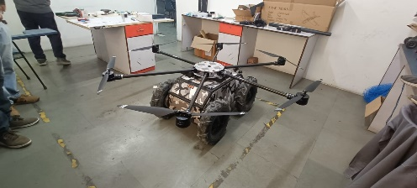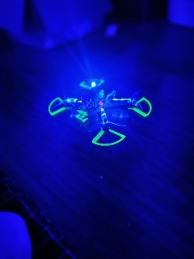

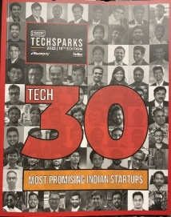

Aside from that, Dtown robotics was also ranked among the 30 most promising deep tech startups of 2022 by YourStory. Each year, yourstory publishes this list as part of their annual event TECHSPARKS, which was attended by the honorable Finance Minister of India this year.