# IHub-Data, IIIT Hyderabad

**TIH on Data Driven Technologies (Data Banks, Services & Analytics)**

# Success Story: Enabling data-driven technological solutions in mobility sector.

1 Introduction

Mobility at iHub-Data aims to identify problems associated with Indian roads and driving conditions using data-driven technologies and create scalable solutions at a national level. The plan is to use applied techniques from machine learning, computer vision, and computational sensing for achieving this aim. The project also aims at aiding transfer of solutions across diverse and often open-ended practical situations, one could anticipate

across India.

The key objectives of Mobility include :

1. enable data driven mobility solutions
2. create technologies for two-wheeler safety in India, and
3. develop scalable road infrastructure inspection

Some of the notable achievements are explained in succeeding sections. 2 India Driving Dataset (IDD)

While several datasets for autonomous navigation have become available in recent years, they were focussed on structured, driving environments. This usually corresponds to well-delineated infrastructure such as lanes, a small number of well-defined categories for traﬃc participants, low variation in object or background appearance and strong adherence to traﬃc rules. Our novel dataset for road scene understanding in unstructured environments, captured from Indian roads, has been created, where the above assumptions are largely not satisfied. Our dataset, a first of its kind, consists of 10,000 images, finely annotated with 34 classes collected from 182 drive sequences on Indian roads. The label set is expanded in comparison to popular benchmarks such as Cityscapes, to account for new classes. The dataset consists of images obtained from a front facing camera attached to a car. The car was driven around Hyderabad, Bangalore cities and their outskirts. The images are mostly of 1080p resolution, but there is also some images with 720p and other resolutions. The dataset has been released in public domain for unrestricted use under public license. This dataset has been featured in data challenges at international tier-1 conferences, national level student challenges and is becoming a defacto dataset for any and all analysis on Indian road scenes. Currently there are nearly 5000 registered users for this dataset across the world.

model hasn’t seen while training. Open World Object Detection on Road Scenes (ORDER) was developed using the India Driving Dataset to address the aforementioned problem for road scenes that could be used in Indian driving conditions.

1. iHUB-Data’s Mobility Car Data Platform (MCDP)

MCDP is a platform with several sensors – cameras, LIDARs, night-vision cameras, RADARs, with necessary compute for anyone to capture, or process data on the car. MCDP is intended to become an car platform of choice, for all researchers, academics, and start-ups in India to test any of their automotive algorithms and approaches in navigation and research on Indian roads. To start with, MCDP 1.0 will feature 6 cameras and 1 LIDAR as sensor for data capture, and gives a full surround view with GPS, and necessary onboard compute for anyone to capture, and process data on the car.

1. Quality assessment of Indian roads

India has one of the largest unstructured road networks in the world. Countries such as India, South East Asia, Africa etc., consists of roads that have one or two lanes and not always well- maintained. Indian roads for instance have obstacles, occluded lane markings, broken dividers, cracks, obstacles, potholes, etc. that puts the drivers at significant risk while driving. Our work focussed on lane and road quality assessment to improve the drivability of the roads. A new framework, LaneRoadNet (LRNet) was designed to address this problem with an integrated mechanism considering lane and road parameters using deep learning. Road quality was analyzed with help of a modular scoring function, where the final score provides the drivability assistance, given the particular instance of the road condition on the above-mentioned factors. It is hoped that the project would help administration to assess road quality and prioritise maintenance schedules.

1. Rejuvenating urban greenery on roadsides

Assessing the number of street trees is essential for evaluating urban greenery and can help local self-government institutions to employ suitable rejuvenation methods in treestarved streets. It can also help identify roads with different levels of deforestation and afforestation over time, providing temporal eﬃciency of rejuvenation efforts. It is hoped that street trees quantification will propel local bodies to carry out afforestation activities to promote greenery. The data collection setup creates visuals of roadside scenes. A unique annotation procedure aimed at robustly detecting and quantifying trees is then deployed. The work centered around a dataset of around 1300 road scenes annotated with over 2500 street trees. The street tree detection, counting and visualization framework was designed that uses object detectors and a matching counting algorithm. The work paved way for a quick, accurate, and inexpensive way to recognize tree-starved streets. The details of the project also has been archived in public domain, taking into accounts its universal appeal. Source code: https://github.com/iHubDataMobility/public-tree-counting .

1. Promoting Mobility across Technical Institutions in India The case study of Mobility as an AI/ML application has been used in the online course Foundations of Modern Machine Learning launched by iHub-Data for all undergraduate engineering students studying in AICTE approved institutions in India. Sub-projects in Mobility are slated to absorb undergraduate engineering students from AICTE approved institutions in India, as interns, in Summer Internship Program about to be launched in 16th of May 2022.

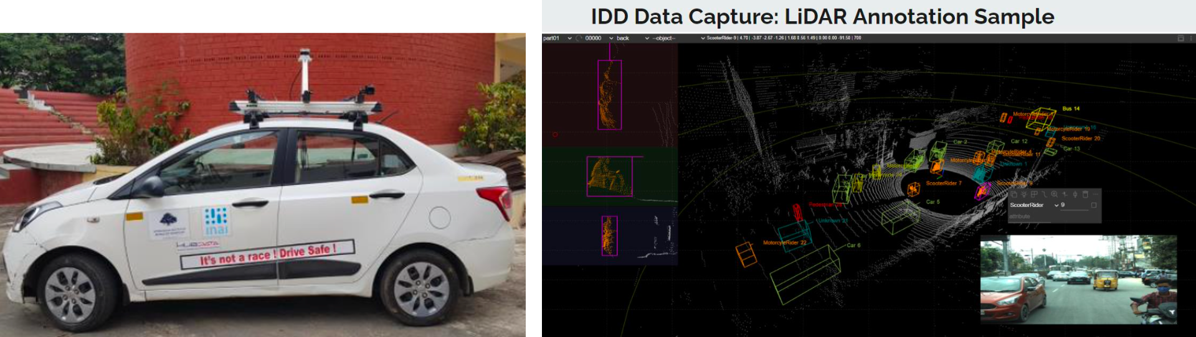

1. Open World Object Detection

Object detection is a key component in autonomous navigation systems that enables localization and classification of the objects in a road scene. Existing object detection methods are trained and inferred on a fixed number of known classes present in road scenes. However, in real-world or open-world road scenes, while inference, one may across unknown objects that the detection