IHUB Data IIIT HYD

UAV-based Visual Remote Sensing for Automated Building Inspection
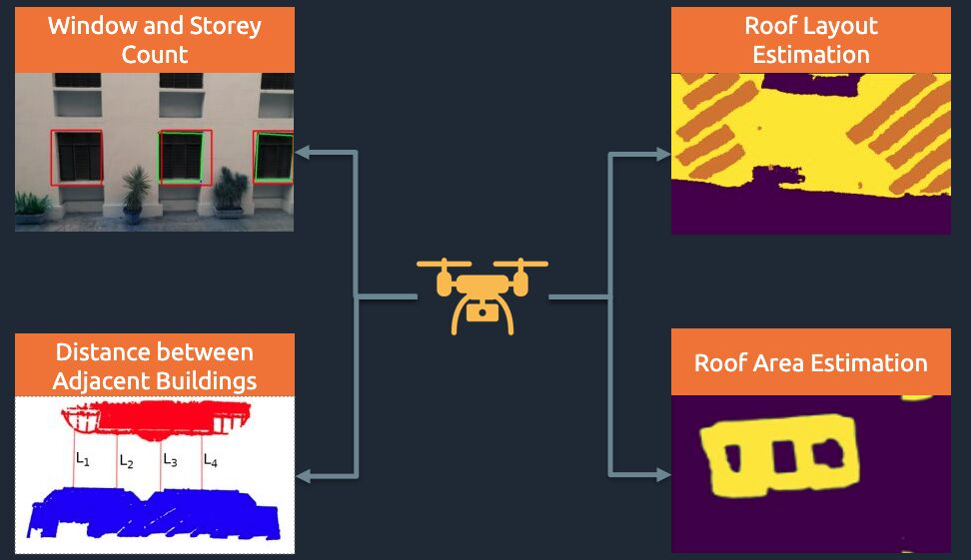
Traditional techniques to analyze the condition and geometric aspects of buildings and other civil structures involve physical inspection by civil experts who need to follow pre-defined standard procedures. Vulnerability of a building to earthquake and consequent risk-assessment, demand inspection that takes into account, expected damage progression of the associated component and the component’s contribution to overall structural system performance. Such inspections conducted in seismically active zones, are of high significance. The downside of such inspections, however, is that they are costly, risky, time consuming, labour and resource intensive.

Unmanned Aerial Vehicles (UAVs) mounted with cameras have a potential for executing contactless, rapid and automated inspection. These UAVs can also monitor civil structures apart from contributing to remote data acquisition. Additionally, these UAVs can be used to obtain information even in inaccessible areas, by taking a large number of images and videos from several points generating different angles of view. UAVs, therefore, promise huge potential when it comes to remote data acquisition for pre and/or post-earthquake risk assessments. Such an arrangement involving UAVs, results in significant reduction of human intervention, and thereby, lower cost of operation, while ensuring effective data collection.

A novel methodology to automate building inspection through UAV-based image data was successfully deployed at IIIT Hyderabad. In addition, a user-friendly Artificial Intelligence (AI) model based software library for processing the collected UAV data has also been developed. The software library helps estimate the seismic structural parameters such as distances between adjacent buildings, shape of buildings, area of buildings, objects on its rooftop and rooftop layout. The method was validated using field measurements, taken using a distance measuring sensor and also from data obtained through Google Earth.

