Achievements – IIT Mandi iHub and HCI Foundation

**Skill Development:** One of the highlights of the skill development program at IIT Mandi iHub is the flagship undergraduate fellowship program named “Anubhav Fellowship.” The program aims to provide undergraduate students with a practical exploration exercise for defined engineering problems in HCI and allied areas. “Anubhav,” which means experience, is an opportunity to enhance learning through solving real-life problems, exploring entrepreneurial skills, and experimenting with innovative solutions. This three-month fellowship which is running into its third batch has attracted students from all across India and is mentored by the expert faculty of IIT Mandi in the area of HCI.

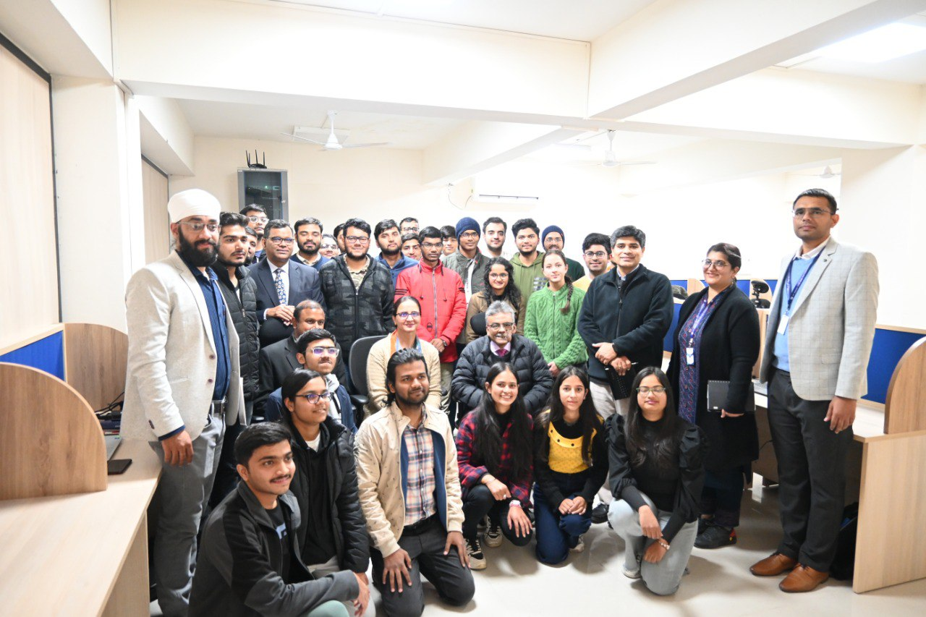

“Anubhav” Fellows of IIT Mandi iHub with DST Leadership Team