Achievements – IIT Mandi iHub and HCI Foundation

1. **Start-ups and Entrepreneurship:** One of the leading start-ups in the Healthtech area, Wellnesys has developed a Smart yoga mat integrated with hardware and software systems for preventive healthcare and fostering rehabilitation based on HCI and using deep learning and advanced computer vision models (<https://wellnesys.com/>). It has been sold in eighteen countries and is an award-winning Healthtech product. It comes in two variants and is available on several e-commerce websites. It is the winner of Oppo Elevate India Demo Day. The start-up is based out of Bangalore and is funded by IIT Mandi iHub and HCI Foundation.

|  |  |
| --- | --- |
|  |  |
| Pic 1- Start-up team Wellnesys interacting with Dr. Akhilesh Gupta and Dr. Ekta Kapoor from DST | |

1. **Skill Development:** One of the highlights of the skill development program at IIT Mandi iHub is the flagship undergraduate fellowship program named “Anubhav Fellowship.” The program aims to provide undergraduate students with a practical exploration exercise for defined engineering problems in HCI and allied areas. “Anubhav,” which means experience, is an opportunity to enhance learning through solving real-life problems, exploring entrepreneurial skills, and experimenting with innovative solutions. This three-month fellowship which is running into its third batch has attracted students from all across India and is mentored by the expert faculty of IIT Mandi in the area of HCI.

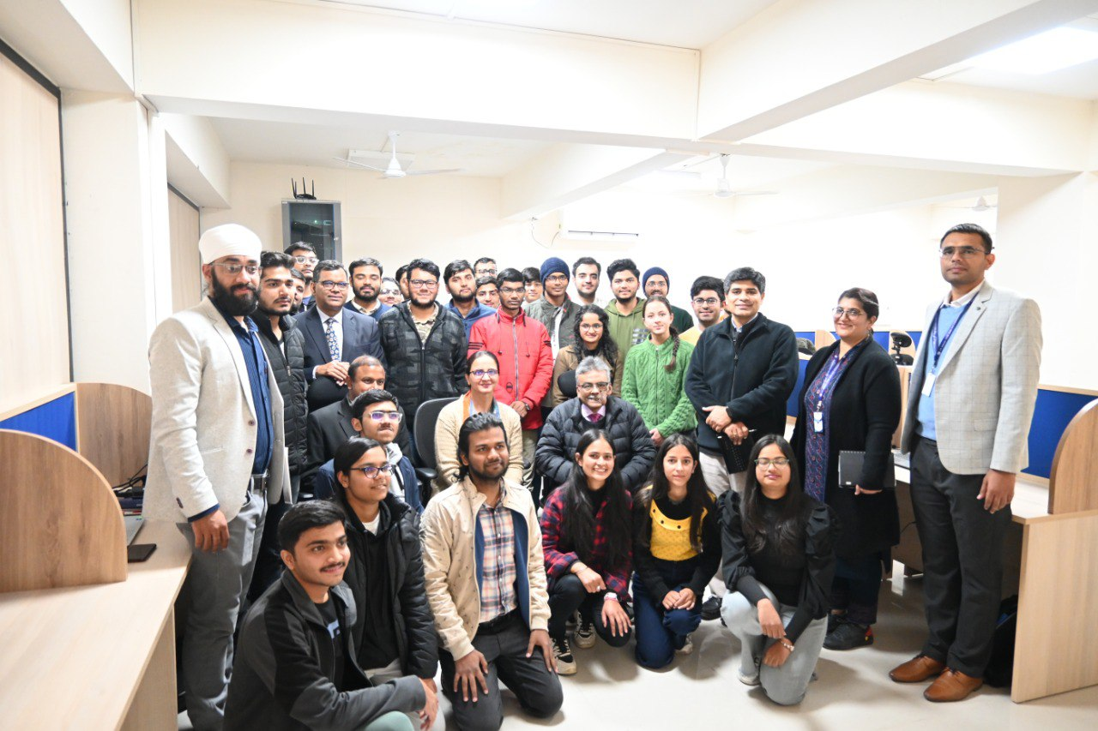

Pic 2 - “Anubhav” Fellows of IIT Mandi iHub with DST Leadership Team

1. **Research and Technology Development:** With the mandate to develop IIT Mandi iHub and HCI Foundation as a Centre of Excellence (CoE) for HCI in India, the research and technology development is in cutting edge technologies which can be translated for adoption by the industry and the betterment of the humankind. One such example is in the area of conversational AI using social robots to address the pre-screening of mental health. To make the solution relevant to the Indian context, the conversation has been programmed in the Hindi language, thereby making it acceptable at a scale for the Indian population.

|  |  |
| --- | --- |
|  |  |
| Pic 3 - Dr. Akhilesh Gupta conversing with the social robot “Furhat” programmed in Hindi | Pic 4 - DST Officials visiting the experience center of IIT Mandi iHub and HCI Foundation |