**News Report: Success Story III**

**Global Online Certification Course on Data-Driven Supply Chain Transformation 2022**

* A lecture series titled “Supply Chain Management” by Prof. David Simchi-Levi, MIT, USA was conducted jointly by I-DAPT Hub Foundation and NITIE, Mumbai.

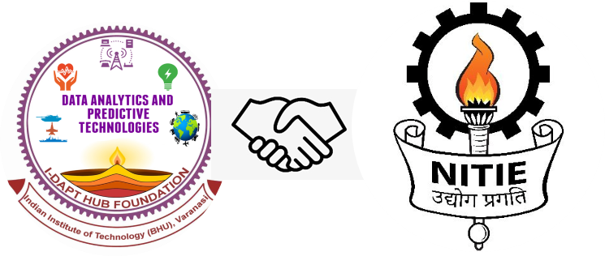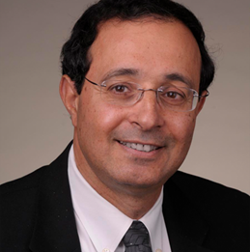

* IIT (BHU), Varanasi, and NITIE, Mumbai, jointly organized the Global Online Certification Course on 'Data-Driven Supply Chain Transformation 2022' in association with Prof. David Simchi-Levi (MIT, USA) under the leadership of Prof. Manoj K. Tiwari (Director, NITIE Mumbai) and Prof. Pramod Kumar Jain (Director, IIT (BHU) Varanasi), to accelerate the vision of PM Gati Shakti.
* The thirty-hour course was conducted from 16th July 2022 to 21st August 2022 on a weekend, in collaboration with I-DAPT Hub Foundation, IIT (BHU), and CoE Logistics & Supply Chain Management, NITIE, under the mission of PM Gati Shakti Scheme.
* This course was promoted, operationalized, and managed completely in-house by the student teams of both institutes under the supervision of the faculty coordinators of both institutes.

**Course Focus comprised of:**

* Supply Chain Trends
* Supply Chain Competency
* Machine Learning based technology
* Digital Supply Chain transformation

**Course content**

**Week I**

* Introduction and Course Overview
* Customer Value and Operations Strategy
* Controlling the Bullwhip and value of Information

**Week II**

* Supply Chain Integration: Push-Pull and Complexity Reduction
* Supply Chain Segmentation

**Week III**

* Using Big Data to Improve Operations
* Applications in Retail, Manufacturing

**Week IV**

* Supply Chain Resiliency
* Supply Chain Flexibility

**Week V**

* Inventory Management and Risk Pooling Strategies
* Supply Contracts and Risk-Sharing Strategies

**Week VI**

* Network Planning and the Green Supply Chain
* IT and Business Processes
* Course Summary

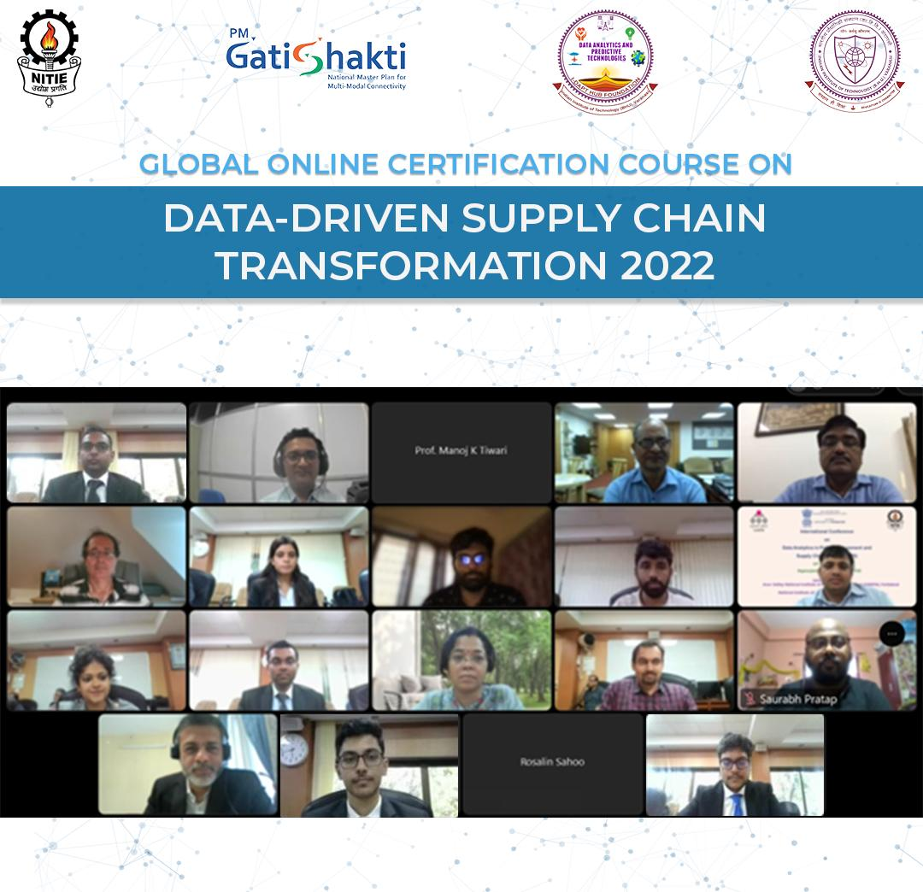

This course was open to all academic and business people. Hence, we have received a huge response from academia and industries. In total, we have received 276 paid participants from academia and industries globally. Further, this course was also open to the students of both institutes for free. A large number of students, 498 from IIT(BHU) and 927 from NITIE registered for this course.

Participants’ details are as follows:

|  |  |
| --- | --- |
| **Category** | **Count** |
| Domestic | 203 |
| Foreign | 9 |
| Student Bulk | 30 |
| Company Bulk | 35 |
| Refunds | -1 |
| ***Paid Total*** | ***276*** |
| Free Reg | 1425 |
| ***Grand Total*** | ***1701*** |

