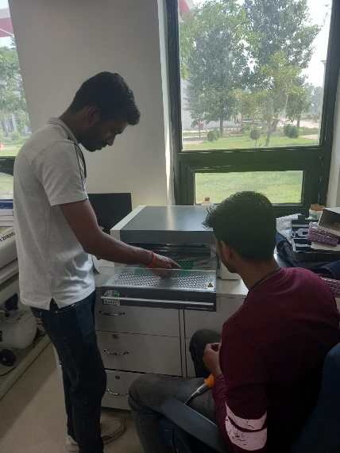

**CPS LAB**

**Introduction**

**Cyber-physical systems (CPS)** play a pivotal role in shaping the future of various industries and societal domains. Their importance lies in their ability to bridge the gap between the digital world of computing and the physical world of machinery and processes. CPS serves as the foundation for Internet **of Things (IoT)**, providing the necessary hardware and software infrastructure to connect and control the physical devices in the IoT ecosystem. The data collected from IoT devices is often processed and analysed by CPS to make real-time decisions and trigger appropriate actions. The IoT lab is one of the crucial elements of the CPS lab.

The IoT lab is a cutting-edge facility created to promote innovation and research in this field. It functions as a focal point for examining the possibilities of networked devices and their effects on numerous businesses because it is outfitted with the most recent hardware, software, and networking infrastructure. The development, experimentation, and testing of IoT technologies and applications are the main goals of an IoT lab, which is a specialized location or workspace. It offers a practical setting for IoT exploration and innovation for academics, engineers and students.

The lab fosters communication and knowledge exchange between academics, workers in the field, and students. It holds training sessions, seminars, and workshops to inform people about IoT principles, technology and best practices. Additionally, it provides a forum for running tests, approving theories, and presenting creative IoT solutions.

Overall, the lab serves as a learning and research centre for students, researchers, and industry professionals interested in exploring and developing innovative IoT solutions for smart homes. The lab provides a hands-on environment for experimenting with various IoT devices, sensors, protocols, and platforms to create efficient and secure smart systems. The IoT lab offers academics and developers a dynamic and immersive environment where they may explore the limitless potential of IoT technology, build cutting-edge applications, and advance the field.

**OBJECTIVES**

The main objectives of the CPS Lab are as follows:

* ***Education and Training:*** To provide professionals, researchers, and students with real-world knowledge and abilities in IoT-related smart technologies.
* ***Research and Development:*** To promote and aid in the research activities in the IoT sector, examining fresh concepts and creating ground-breaking solutions.
* ***Prototyping and Testing:*** To offer a platform for the prototyping and testing of IoT gadgets, sensors, and smart solutions software.
* ***Collaboration:*** Encourage students, researchers, business leaders, and other stakeholders to work together to share information and create cutting-edge IoT solutions.

*CPS - IoT Lab Hardware Setup*

|  |  |  |
| --- | --- | --- |
| **Sr.**  **No.** | **Hardware** | **Description** |
| 1 | BLE Gateway | A BLE (Bluetooth Low Energy) gateway is a device or system that serves as an intermediary between BLE devices and other networks or systems. BLE is a wireless communication technology designed for low-power, short-range communication, making it ideal for applications such as Internet of Things (IoT) devices, wearable devices, and various sensor networks. The purpose of a BLE gateway is to facilitate the communication between BLE devices and other networks, such as local area networks (LANs), cloud services, or other IoT platforms. |
| 2 | BLE Development Kit | It is a single-board development kit (DK) for Bluetooth Low Energy and Bluetooth mesh, 2.4 GHz proprietary applications using the nRF52832 SoC |
| 3 | BLE Node | The BLE nodes are peripheral devices equipped with NRF52 microcontrollers or other BLE-enabled devices. These nodes can be sensors, actuators, or any other devices that need to communicate with the gateway. Each BLE node is capable of establishing a Bluetooth connection and transmitting data to the gateway. |
| 4 | Grove Shield | Grove shield is a modular, simple-to-use system designed to easily connect a BLE development kit to a wide range of “modules” such as sensors, motors, and inputs. |
| 5 | 4G/5G Kit | The 4G module enables the connectivity to high-speed LTE, HSPA+, WCDMA cellular networks in order to make possible the creation of the next level of worldwide compatible projects inside the new "Internet of Things" era. |
| 6 | Sensors | Sensors come in the breakout boards. They have pins on them, which are used for supplying the power, providing ground, receiving inputs, and sending outputs. Breakout boards, in a nutshell, make using a single electrical component, sensor, or chip simple and easy. Different types of sensors are available with the kit like Temperature, Humidity, Accelerometer, Relay, Memory |
| 7 | UART to USB Converter | A UART to USB converter is a type of [protocol converter](https://en.wikipedia.org/wiki/Protocol_converter) that is used for converting UART signal to [USB](https://en.wikipedia.org/wiki/USB) data signals. |
| 8 | Breadboards | A breadboard, solderless breadboard, or protoboard is a construction base used to build semi-permanent prototypes of electronic circuits. |
| 9 | Jumper Wires | These are used to connect any circuit on the breadboard. |
| 10 | LED’s , Resistors etc. | For verification purposes or for indication purposes, LED’s are the best medium to visualize the output. |