# IHub-Data, IIIT Hyderabad

**TIH on Data Driven Technologies (Data Banks, Services & Analytics)**

# Success Story: Intelligent Solutions for Road Safety through data driven Technology & Engineering.

1. Introduction

Loss of lives due to road accidents has always been a matter of great concern in India. Intelligent Solutions for Road Safety through Technology and Engineering (iRASTE) is an ambitious project conceived by a consortium consisting of INAI (Applied AI Research Institute), Intel, iHub-Data, IIIT Hyderabad, CSIR-CRRI (Central Road Research Institute), Mahindra and Mahindra, and the Nagpur Municipal Corporation. The project which aims to reduce road accidents up to 50 percent in the city of Nagpur by leveraging iRASTE over a period of two years, was inaugurated on September 2021 by Hon Union Minister of Road Transport, Shri Nitin Gadkari.

1. Objectives

The three broad objectives of iRASTE include :

1. vehicle safety - improving safety of public fleet by reducing road crashes and fatalities leveraging AI solutions,
2. mobility analysis - performing proactive identification of potential road crash prone locations i.e., grey spots using Advance Driver Assistance System (ADAS) data and
3. infrastructure safety - developing remedial measures i.e., countermeasures for the identified existing blackspots and continuous monitoring of road assets.

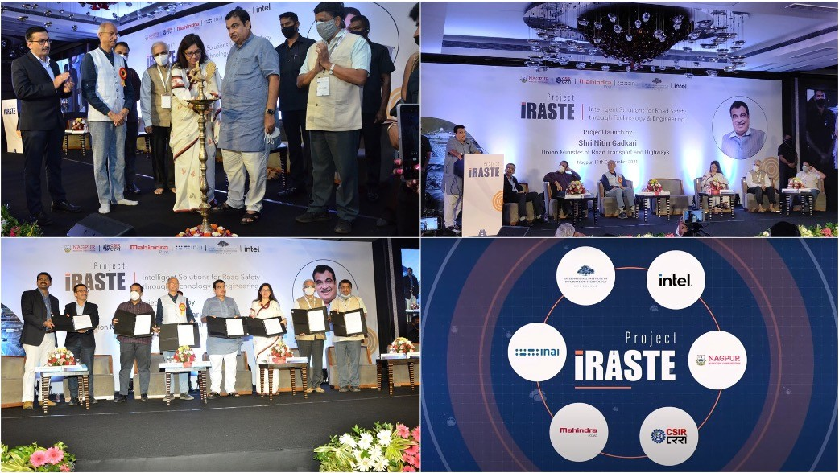

1. Consortium Specialities

All the consortium partners had very specific roles to play in the project. INAI facilitated the industry partnership focussing on finding applications to sophisticated AI in everyday problems especially at the national level. IIITH brought in its wide expertise in AI to the fore. With Intel as one of the main collaborators, IIITH has been working over the past few years in creating datasets for Indian driving conditions, now popularly known as the IDD or Indian Driving Dataset, which were helpful for researchers to develop their own algorithms. Intel India also brought onboard, systems based on Advanced Driver Assist System (ADAS) technology, CSIR-CRRI brought domain expertise in road engineering, Mahindra & Mahindra, with their vast experience of driving major road initiatives conducted road safety public awareness programs and driver training in Nagpur and iHub-Data facilitated the activities ensuring that the project didn’t face any major hurdles.

1. Advanced Driver Assist System (ADAS)

With the aim of reducing rate of accidents in India, the consortium conducted pilot studies of ADAS technology by Mobileye (an Intel company) where a camera mounted on the windshield of a vehicle scanned the entire road ahead using complex AI algorithms to track potential risks to safety. If the system detected a potential risk of collision, it generated an audio as well as visual warning to the driver. For instance, if the driver got too close to the vehicle ahead, a warning would reach the driver, causing vehicle to slow down and maintain a safe following distance. Warning would also be sounded in case of a potential risk of colliding with pedestrians, cyclists or even stray animals. In the event of veering away from designated lane without signalling, the system would provide an alert to prevent such unintentional drifting.

1. Identification of Grey Spots

For project iRASTE, the Nagpur Municipal Corporation adopted the collision avoidance technology in a fleet of its intra-city buses. The primary goal for this had been to reduce accidents and casualties through modification of driver behaviour via the use of assistive technology. Additionally, the project also leveraged the predictive power of AI for fixing road infrastructure. While black spots could be identified with the help of statistics, iRASTE, adopted a pro-active approach by identifying potential risk in certain zones, flagging these as grey spots using special sensors, which could be used effectively before such spots get promoted to more riskier black ones. Here with the help of inputs from CSIR-CRRI, suitable approaches in road re-engineering would help prevent more fatalities from such zones. One of the most innovative and life-saving aspect of Project iRASTE is the addition of a preventive element to the traditional corrective element for road infrastructure improvements.

1. Uniqueness of iRASTE

What makes the solution even more unique is that the sophisticated technology has been especially adapted to suit Indian conditions. Datasets for traﬃc in western countries cannot be applied to Indian roads. While the initial rollout of iRASTE is in Nagpur, the eventual goal is to replicate the solution in other cities too. Currently, talks are on with the Telangana government to adopt the technology in a fleet of buses that ply on highways. 50% of accidents happen on highways which constitute only 5% of the Indian road network.Therefore, implementing iRASTE on highways is high on priority for reducing accidents and thereby, fatalities.

1. Driver Training

Nagpur Municipal Corporation has put in place a training mechanism for drivers through its “Defensive Driving and Driver Assistance through Artificial Intelligence” programme, especially targeting drivers of large commercial vehicles such as buses. This was done with the assistance of Ashok Leyland Institute for Driver Training And Research (ALIDTR). Defensive driving is a strategy that goes well beyond mere following of road laws and regulations. It involves the conscious practice of safe driving techniques in a bid to pre-empt accidents. Most drivers have remarked that the alerts provided by the Collision Avoidance Systems helped in promoting defensive driving behaviours such as lane discipline and adherence to the speed limits. In addition to this, a subset of drivers are selected to undergo the Vienna Test to understand the individual reactions which would in turn be helpful in fine tuning the Collision Avoidance System.

1. Action Plan for next 6 months
2. Vehicle safety - 50 vehicles have been running for past six months on CAS device. Another 200 vehicles would be equipped with CAS.
3. Mobility Analysis - Around 20 greyspots have been identified using AI and data insights. NGO partner, Yuva Daud Manch will start a 30-day awareness program at the top 5 grey spots. (c)Infrastructure safety - Identified 37 blackspots that conform to MoRTH protocol. High level action plan for all 37 black spots are under preparation. NGO partner Yuva Daud Manch would commission Disaster Management Centers are the top 5 black spots to help accident victims.

(d) Development of Road Safety Index (RSI) and Road Quality Index (RQI) is planned. Also planned is extending scope of iRASTE beyond Nagpur, by including Goa, Gujarat and Telengana.

1. Promoting case study of iRASTE

The case study of iRASTE as an AI/ML application has been used in the online course Foundations of Modern Machine Learning launched by iHub-Data for all undergraduate engineering students studying in AICTE approved institutions in India. iRASTE is an ever improving AI/ML project which also is slated to absorb undergraduate engineering students from AICTE approved institutions in India, as interns, in Summer Internship Program of IIIT Hyderabad.