Achievements – IIT Mandi iHub and HCI Foundation

Research and Technology Development: With the mandate to develop IIT Mandi iHub and HCI Foundation as a Centre of Excellence (CoE) for HCI in India, the research and technology development is in cutting edge technologies which can be translated for adoption by the industry and the betterment of the humankind. One such example is in the area of conversational AI using social robots to address the pre-screening of mental health. To make the solution relevant to the Indian context, the conversation has been programmed in the Hindi language, thereby making it acceptable at a scale for the Indian population.

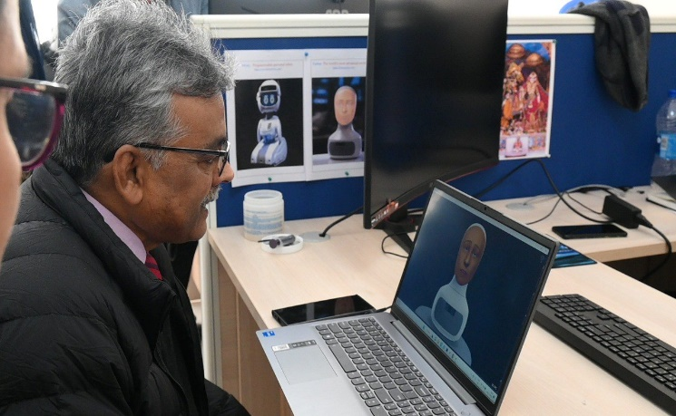 | 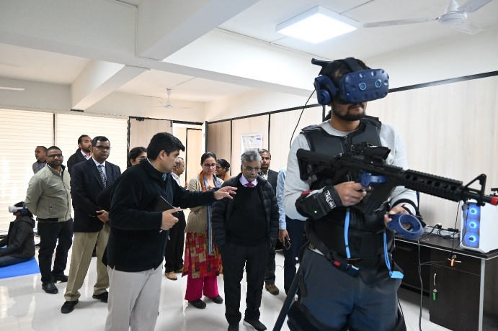
Dr. Akhilesh Gupta conversing with the social robot “Furhat” programmed in Hindi | DST Officials visiting the experience center of IIT Mandi iHub and HCI Foundation

