Achievements – IIT Mandi iHub and HCI Foundation

Start-ups and Entrepreneurship: One of the leading start-ups in the Healthtech area, Wellnesys has developed a Smart yoga mat integrated with hardware and software systems for preventive healthcare and fostering rehabilitation based on HCI and using deep learning and advanced computer vision models (https://wellnesys.com/). It has been sold in eighteen countries and is an award-winning Healthtech product. It comes in two variants and is available on several e-commerce websites. It is the winner of Oppo Elevate India Demo Day. The start-up is based out of Bangalore and is funded by IIT Mandi iHub and HCI Foundation.
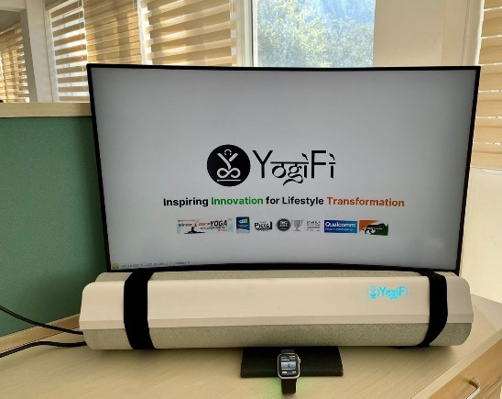 | 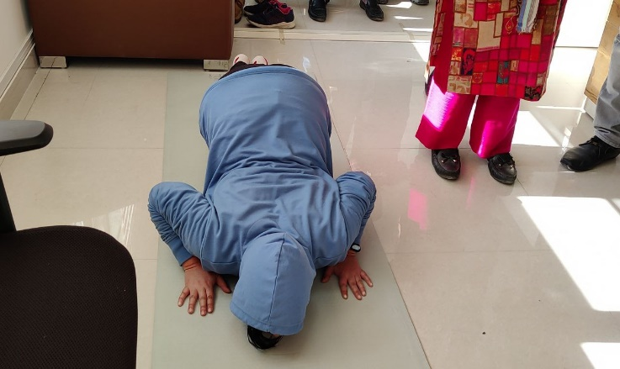
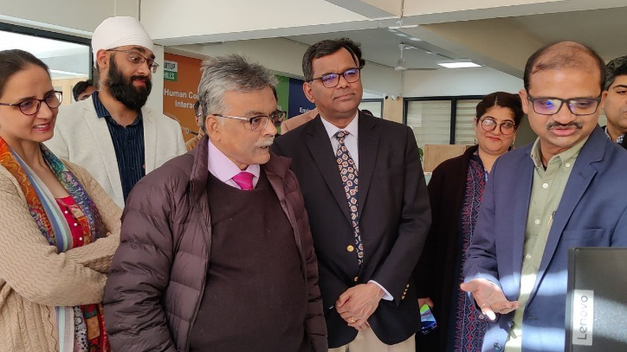
Pic 1- Start-up team Wellnesys interacting with Dr. Akhilesh Gupta and Dr. Ekta Kapoor from DST

