**I-DAPT HUB FOUNDATION, IIT (BHU) Varanasi**

**Demonstrable Prototype of Vehicular Pollution Monitoring System**

A demonstrable prototype of a real-time onboard vehicular exhaust gas monitoring system has been developed. This system uses the signature pattern analysis of the volatile organic compounds (VOCs) using artificial intelligence (AI) based algorithms. Predictive maintenance through signature analysis of the VOCs present in the vehicular exhaust pipe gases is captured by using an onboard vehicular pollution monitoring system (VPMS). An array of 8 non-selective tin-oxide-based gas sensing elements has been designed that is broadly optimized for respective gases. Signature patterns of the vehicular exhaust gases are then captured and analyzed for various exhaust constituents using labeled data and a high-performance AI model is trained and embedded in the onboard processor. This unit is named an ‘intelligent vehicular pollution monitoring system (iVPMS)’. The iVPMS transmits real-time inferences along with the raw sensor responses onto the cloud which in turn, sends these results to the user’s app for necessary observation and compliance.

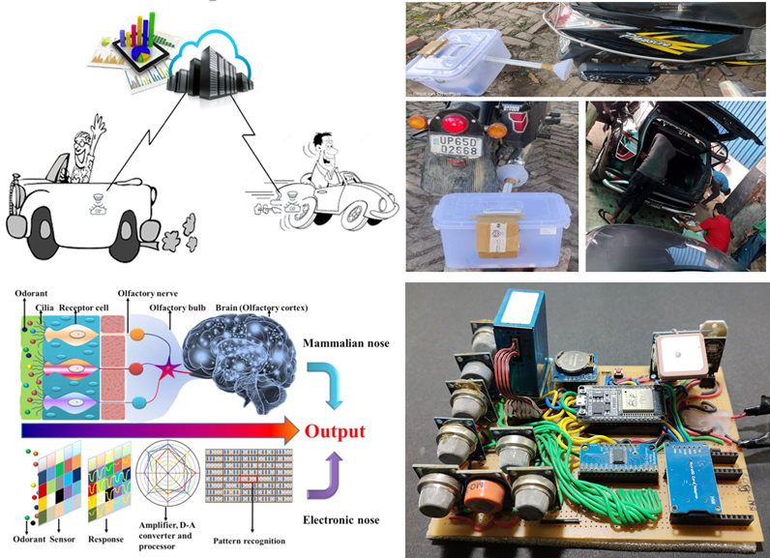

**Pic 3:** Demonstrable Prototype of Vehicular Pollution Monitoring System

1. **IoT Based Smart Grid**

A 2.5 kW solar-integrated smart grid is being implemented at the library building of IIT BHU. The planned smart grid will have IoT-enabled technologies with which devices can be controlled remotely. A new type of converter topology has been developed that can take power from solar PV and give three simultaneous outputs i.e. 1) 230V, 50 Hz AC, 2) 90 V dc, and 3) 5V DC. With this smart grid Laptop, a mobile phone battery can be charged directly without local adopters. The smart grid will have a grid/off-grid mode of operations for source/load optimization. The generated power of solar PV can be fed to the grid using IoT-enabled smart devices. This pilot development work is under process and is expected to be completed soon.

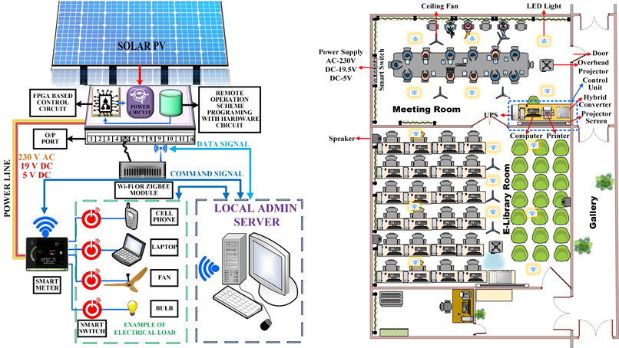

**Pic 4:** Representative model and top view of the IoT Based Smart Grid site