**INPUTS for DST Annual Report – NM-ICPS**

**I-DAPT HUB FOUNDATION, IIT (BHU) Varanasi**

**IoT Based Smart Grid**

A 2.5 kW solar-integrated smart grid is being implemented at the library building of IIT BHU. The planned smart grid will have IoT-enabled technologies with which devices can be controlled remotely. A new type of converter topology has been developed that can take power from solar PV and give three simultaneous outputs i.e. 1) 230V, 50 Hz AC, 2) 90 V dc, and 3) 5V DC. With this smart grid Laptop, a mobile phone battery can be charged directly without local adopters. The smart grid will have a grid/off-grid mode of operations for source/load optimization. The generated power of solar PV can be fed to the grid using IoT-enabled smart devices. This pilot development work is under process and is expected to be completed soon.

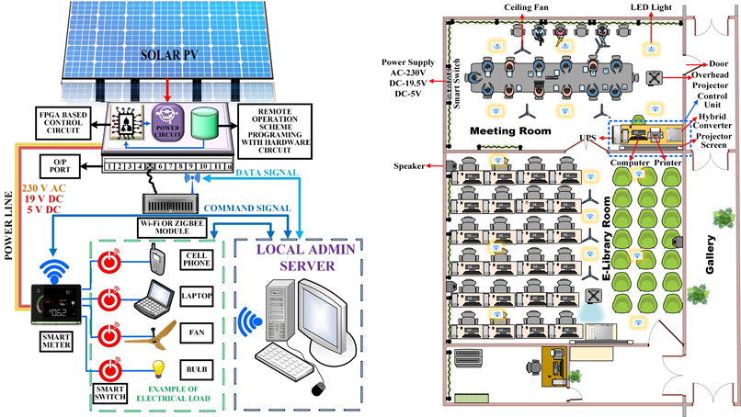

**Pic 4:** Representative model and top view of the IoT Based Smart Grid site