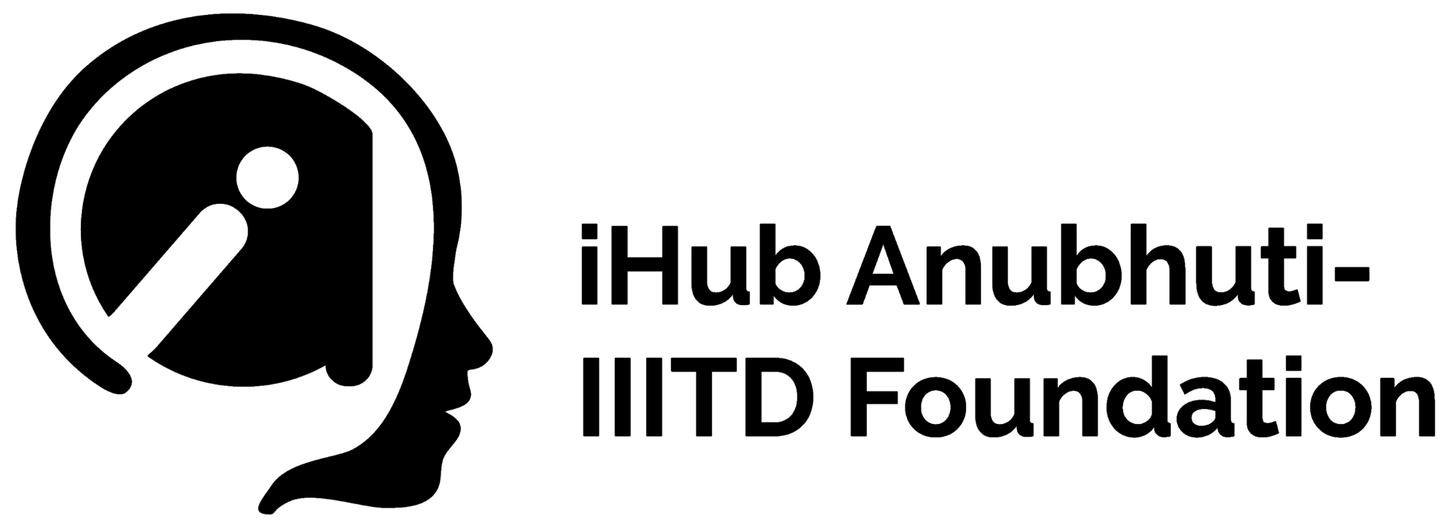

**SOCIAL MEDIA ANALYSIS**

Total number of followers for top 10 iHubs

| **Name of the Institute** | **Number of Followers in October** | **Number of Followers in November** | **Percentage Change** |
| --- | --- | --- | --- |
| IIIT Hyderabad | 10242 | 10,381 | 1.4% |
| IISC Bengaluru | 6561 | 6860 | 4.6% |
| IIT Roorkee | 6538 | 6570 | 0.5% |
| IIT Kanpur | 5309 | 5392 | 1.6% |
| IIT Bombay | 4338 | 4723 | 8.9% |
| IIT Ropar | 3795 | 4078 | 7.5% |
| IIT Dhanbad | 3225 | 3293 | 2.1% |
| IIT Palakkad | 3169 | 3235 | 2.1% |
| IIIT Delhi | 3051 | 3722 | 22% |
| IIT Delhi | 2680 | 2812 | 4.5% |
| IIT Madras | 2191 | 2286 | 4.3% |

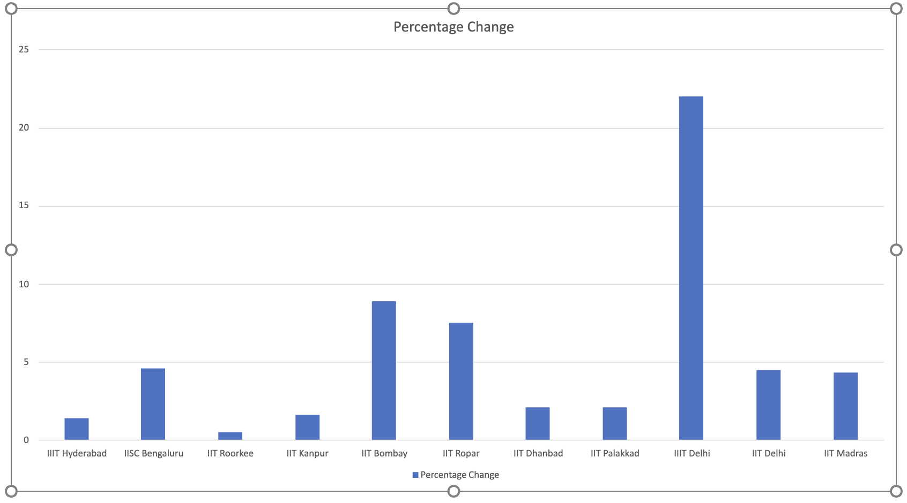

Findings: iHub Anubhuti IIITD Foundation (TIH, IIITD) jumped from ninth place to seventh place in a month

**Follower Metrics in the last 30 days (about 4 and a half weeks)**

Organic Metrics for Total Engagements in last 30 days (about 4 and a half weeks)

**OCTOBER**

**NOVEMBER**

**Memorandum of Understanding signed by iHub Anubhuti - IIIT Delhi Foundation: We are actively collaborating with academic institutions to foster research and expertise in Cognitive Computing and Social Sensing.**

**Memorandum of Understanding, signed by iHub Anubhuti - IIITD Foundation**

| **S.no.** | **Name of the Institute** | **Vertical** |
| --- | --- | --- |
| **1.** | **Ministry of Rural Development** | **Sector Agnostic** |
| **2.** | **All India Council of Technical Education** | **Education** |
| **3.** | **Health Parliament** | **HealthCare** |
| **4.** | **ExperiHub Ventures** | **Education** |
| **5.** | **Shoolini University** | **Education** |
| **6.** | **Bennett University** | **Education** |
| **7.** | **NIMS University** | **Education** |
| **8.** | **Max Healthcare** | **HealthCare** |

**INTERNATIONAL COLLABORATIONS by iHub Anubhuti - IIITD Foundation**

Memorandum of understanding for Academic Cooperation

**between**

**Temerty Faculty of Medicine, University of Toronto, Toronto, Canada**

**and**

**Indraprastha Institute of Information Technology, New Delhi, India**

| **WEBINARS** | | |
| --- | --- | --- |
| S.no. | Date | Title |
| 1. | June 21, 2022 | Guaranteed Adversary Robust Training of Neural Networks |
| 2. | May 4, 2022 | Making Invisible Visible with Data, ML, and Devices |
| 3. | March 14, 2022 | Machine Learning and Logic: Fast and Slow Thinking |
| 4. | Feb 23, 2022 | Trans Evolve: A Tale of Transformer and Multi-particle Dynamical Systems |
| 5. | Date: Jan 25, 2022 | AI in Blood Cancer Imaging |
| 6. | December 20, 2021 | Understanding the Semantic Web and its Applications |
| 7. | November 24, 2021 | Towards Artificial Vikramaditya: Can Machines Deliver and Explain Fair  Judgments |
| 8. | September 29, 2021 | How We Built Machine Intelligence To Help Doctors Save Lives |
| 9. | August 25, 2021 | Intelligent Biomedical Image Analysis |
| 10. | July 28, 2021 | Machine Learning for Healthcare: Cancer to CoVID |

| **WORKSHOPS** | | |
| --- | --- | --- |
| S.no. | Workshop Name | Number of Participants |
| 1 | Anveshan Hackathan 2022 | 131 |
| 2 | Data Quality for AI | 60 |
| 3 | AI for Computational Social Systems | 60 |

| **NEWSLETTER** | | |
| --- | --- | --- |
| S.no. | Issues | Month |
| 1. | Issue No. 1 | September 2021 (The inaugural version of the newsletter) |
| 2. | Issue No. 2 | November 2021 |
| 3. | Issue No. 3 | January 2022 |
| 4. | Issue No. 4 | March 2022 |
| 5. | Issue No. 5 | May 2022 |

| **BLOGS** | |
| --- | --- |
| 1. | Cognitive computing for a better world by iHub Anubhuti Team |
| 2. | Cognitive computing in Education By Vikram Goyal, Project Director |
| 3. | Cognitive computing Trends and Innovation in Legal Domain by Tanmoy Chakraborty, Project Director |
| 4. | EngageMe: Multimodal Analysis of Attention among Children with Attention Deficit  Hyperactivity Disorder for Digital Learning by Jainendra Shukla, Project Investigator |
| 5. | Cognitive computing/AI/ML trends and innovations in Health, iHub Anubhuti Team |
| 6. | Counseling conversation summarization, iHub Anubhuti Team |