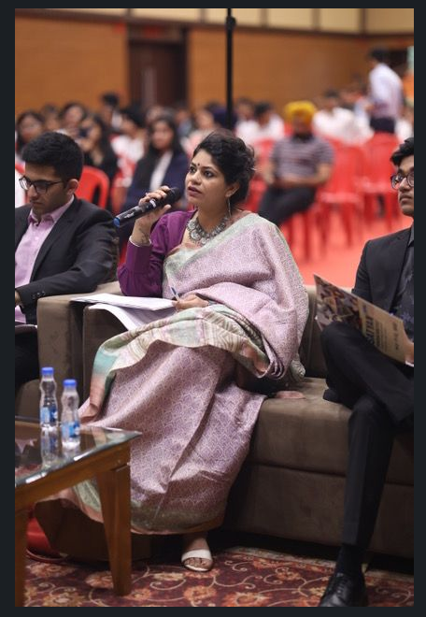

The innovation ecosystem is thriving in our secondary education system. Schools are taking impactful measures to spur the spirit of [innovation](https://www.linkedin.com/feed/hashtag/?keywords=innovation&highlightedUpdateUrns=urn%3Ali%3Aactivity%3A7065008062314536961) and [entrepreneurship](https://www.linkedin.com/feed/hashtag/?keywords=entrepreneurship&highlightedUpdateUrns=urn%3Ali%3Aactivity%3A7065008062314536961) in school children. [iHub - AWaDH](https://www.linkedin.com/company/ihub-awadh/)  is reaching out to schools and bringing awareness about innovation and entrepreneurship amongst young children from class VII to class XII.   
  
It was extremely exhilarating to be part of Satyan Innovation and Entrepreneurship Fest (SIF) 3.0, powered by [WHIZROBO](https://www.linkedin.com/company/whizrobo/) at Sat Paul Mittal School, Ludhiana.   
  
[Dr Radhika Trikha](https://www.linkedin.com/in/ACoAABoJWXUBIy6NU0AuXkN4MCg3Wjk9pKrHZDY) along with other jury members and Maha Mentors [Vineet Khurana](https://www.linkedin.com/in/ACoAAAX7ZBUBrAmkwr0ZsNfmPRwICUU8EBXUuUk) Dr J K SHARMA [Ashutosh A Mahajan](https://www.linkedin.com/in/ACoAAAR4L8UBMXuU1h3Tih_i31HB5v9Q26lWA20) [Lottie Mukuka](https://www.linkedin.com/in/ACoAABuIT80B60coVEB_rLuluA9uJtTVhGwYsaE) Dr Sandeep Verma engaged in evaluating budding entrepreneurs on their interesting startup ideas exploring the world of [ArtificialIntelligence](https://www.linkedin.com/feed/hashtag/?keywords=artificialintelligence&highlightedUpdateUrns=urn%3Ali%3Aactivity%3A7065008062314536961) and celebrating the entrepreneurial spirit amongst our younger generation.   
  
iHub - AWaDH look forward to supporting our school education system to bring awareness and outreach, and equip young students to explore [CyberPhysicalSystems](https://www.linkedin.com/feed/hashtag/?keywords=cyberphysicalsystems&highlightedUpdateUrns=urn%3Ali%3Aactivity%3A7065008062314536961) to solve our day-to-day problems.