**Glimpse of Public Outreach Activity**

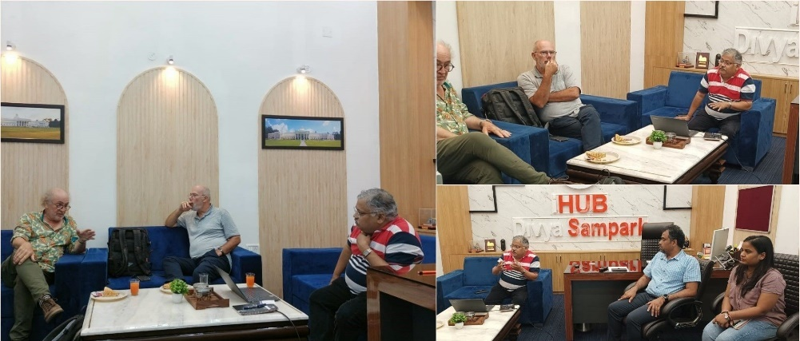

On the ongoing national mission on interdisciplinary cyber-physical systems, we iHUB DivyaSampark @ IIT Roorkee discussed ways that both institutions can collaborate or work together on new technologies to meet the world's future needs and be future-ready.

We would like to thank Dr. Stephana Calmant, Dean of the IRD research center in Cayenne, France, and Dr. Jacques Verron, Director of Research, CNRS, LEGI/LGGE, Grenoble, France, for visiting us.

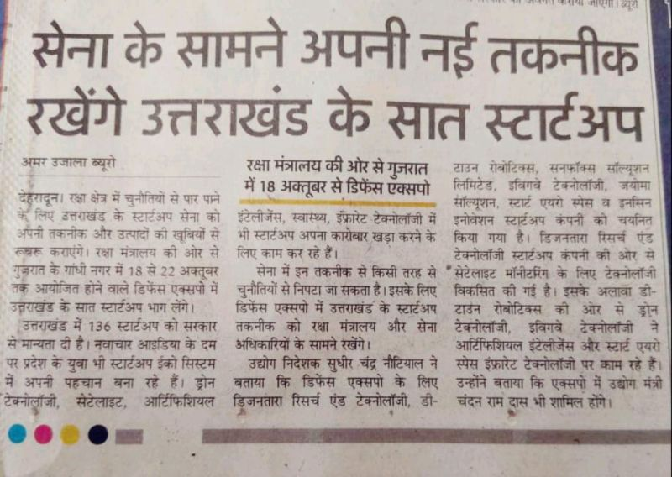

Out of 7, 3 are incubated at iHUB DivyaSampark @ IIT Roorkee

Two startups connected to [iHUB DivyaSampark @ IIT Roorkee](https://www.linkedin.com/company/divyasampark-ihub-roorkee-for-devices-materials-and-technology-foundation/) making into the list of top 30 deep-tech startups

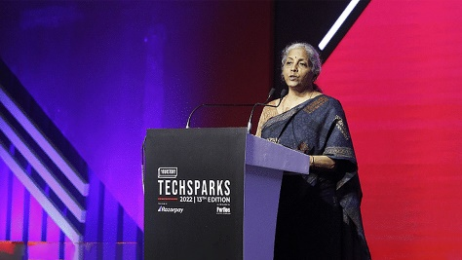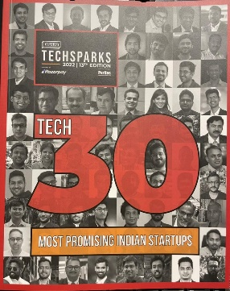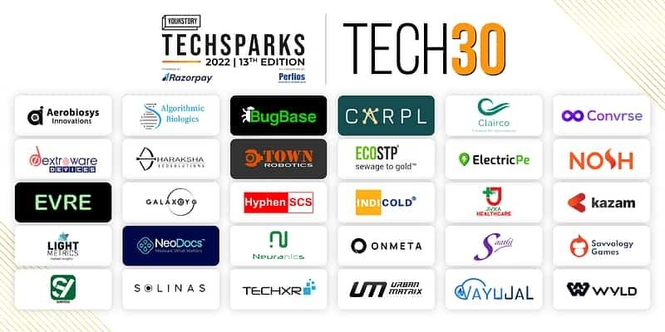

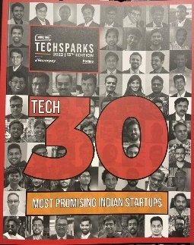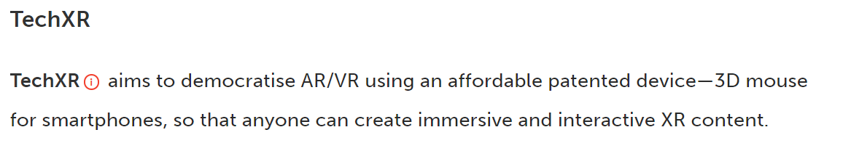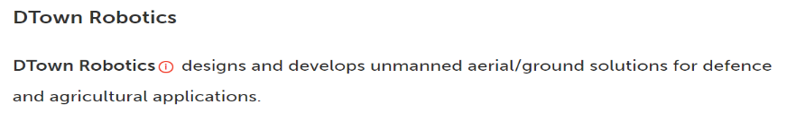

<https://yourstory.com/2022/11/yourstory-unveils-tech30-techsparks2022>

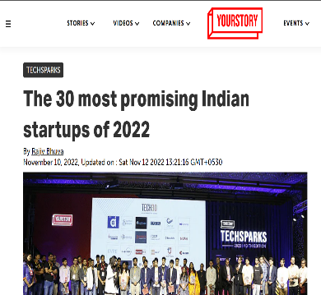

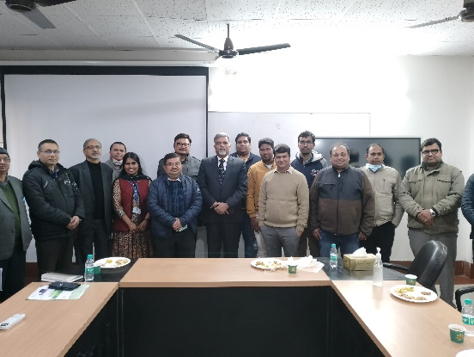

[Indian Institute of Technology, Roorkee](https://www.linkedin.com/company/indian-institute-of-technology-roorkee/) and [iHUB DivyaSampark @ IIT Roorkee](https://www.linkedin.com/company/divyasampark-ihub-roorkee-for-devices-materials-and-technology-foundation/) was lucky to host dynamic Secretary of [Technology Development Board](https://www.linkedin.com/company/tdbgoi/) (TDB) , Govt of India, Shri Rajesh pathak sir. He interacted with our startups and professors and shared his wisdom.

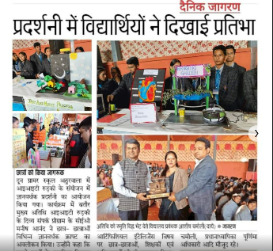

Helping young minds to understand the importance of new age technologies and innovation. Interacted with around 600 students (6th to 11th Std.) of a school near Dehradun.

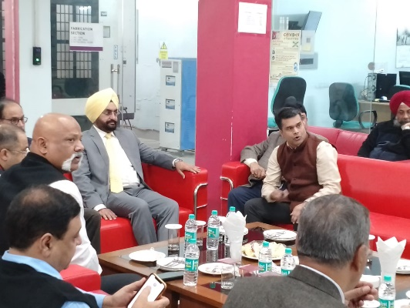A High-level delegation of Uttarakhand Govt. headed by Chief Secretary visited [Indian Institute of Technology, Roorkee](https://www.linkedin.com/company/indian-institute-of-technology-roorkee/) . I got a chance to explain how IITR and [iHUB DivyaSampark @ IIT Roorkee](https://www.linkedin.com/company/divyasampark-ihub-roorkee-for-devices-materials-and-technology-foundation/) are building an innovation ecosystem in futuristic technologies by bringing all the stakeholders together. IT Secratary and ADG UK police (Amit Sinha Sir) also joined. We also discussed how state government can play an active role in the National mission on futuristic technologies.

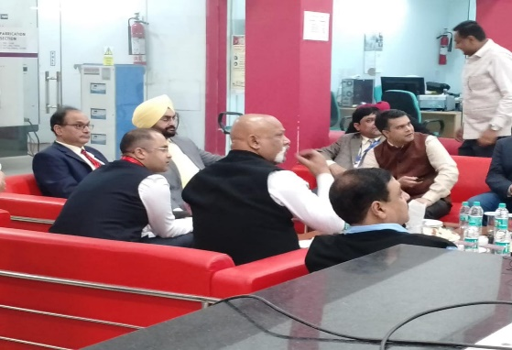

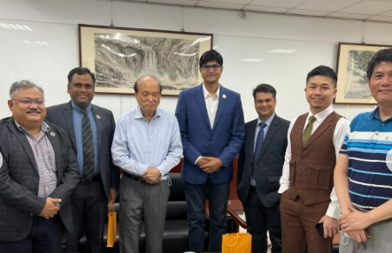Taiwan is the Mecca of Semiconductor devices and material related innovation. Being the only TIH that is focusing on devices, materials and Technology, this visit to Taiwan has a special significance for [iHUB DivyaSampark @ IIT Roorkee](https://www.linkedin.com/company/divyasampark-ihub-roorkee-for-devices-materials-and-technology-foundation/) . We met industry representatives, NYCU innovators, Taiwan semiconductor research Institutes and Hsinchu Science park's officials to understand Taiwanese innovation ecosystem. Expecting great outcomes in the near future. We already have one MoU and few more are expected soon. We are also hoping that TIH at Roorkee will also play an active role in making 'India semiconductor Mission' a great success.

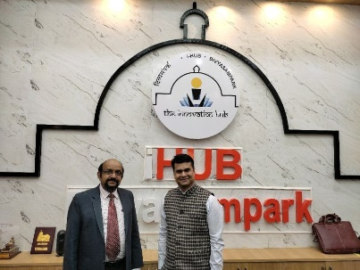

Prof. Kamalanath Samarakoon (Department of Computer Engineering, University of Peradeniya, Sri Lanka) visited us. [iHUB DivyaSampark @ IIT Roorkee](https://www.linkedin.com/company/divyasampark-ihub-roorkee-for-devices-materials-and-technology-foundation/) will support this Sri Lankan university in creating iHUB DivyaSampark like structure at University of Peradeniya.

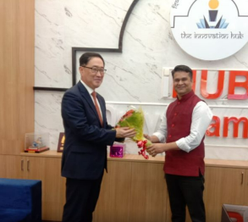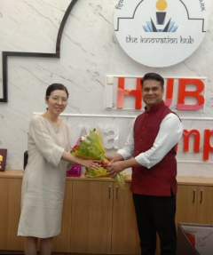

It was nice to host Mr. Park and Ms Lee from Korean embassy. We discussed how [iHUB DivyaSampark @ IIT Roorkee](https://www.linkedin.com/company/divyasampark-ihub-roorkee-for-devices-materials-and-technology-foundation/) and IITR can play a role in connecting innovation ecosystem of Korea and India. We specially discussed collaboration in Drone and semiconductor technology.

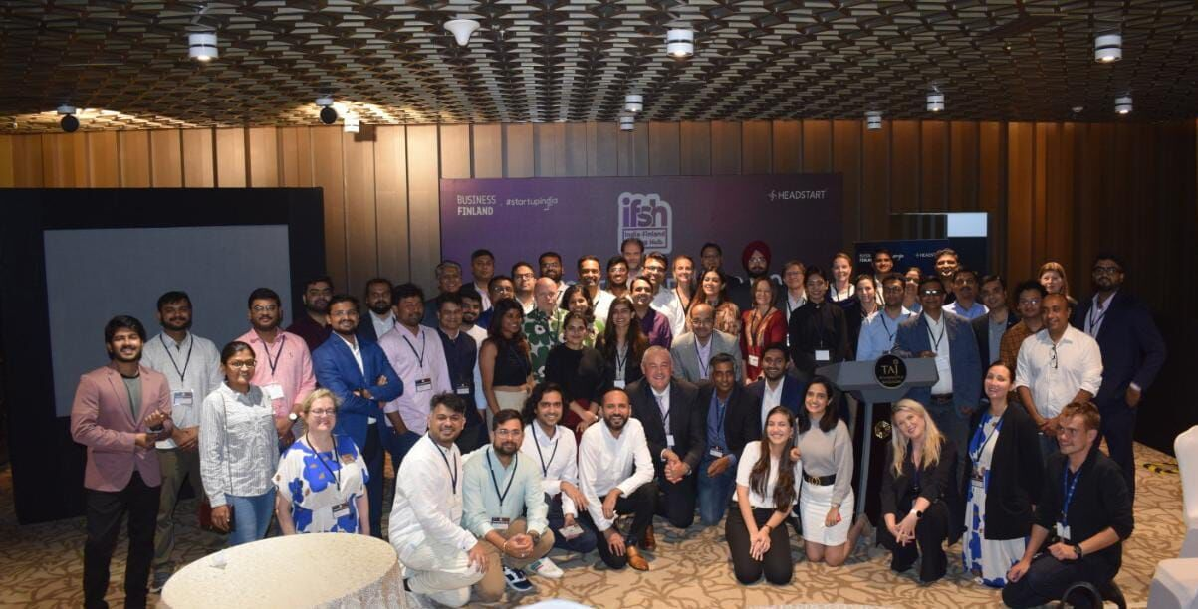Attended "India - Finland innovation ecosystem meet up" organized by Finish embassy at Taj, Bangalore. Many people from Finland were surprised to know about the forward looking missions like NMICPS initiated by Govt of India. Expecting some good collaborations in near future with similar set ups in Finland.