# Pravartak Kalvi Shakthi Rural Interaction Centres

Pravartak Kalvi Shakthi Rural Interaction Centres (RIC) focuses on bringing the best teachers to rural students through technology. We establish a village study centre with a smart TV and internet connection. RICs cater to students of 8th, 9th, 10th, 11th and 12th.  The live online classes are conducted from evening 6 pm to 8 pm. Experienced teachers teach Science, English and Maths in the mother tongue Tamil.

Currently, we have 43 villages covered under this program, and we plan to expand to 100 towns by this year. Through these RICs, more than 1000 students benefit directly. The same RIC teachers conduct daytime online live classes; many schools relay these live classes using their existing infrastructure. By this, currently, more than 800 students benefit directly. All sessions are recorded and uploaded on YouTube for further reference by students.

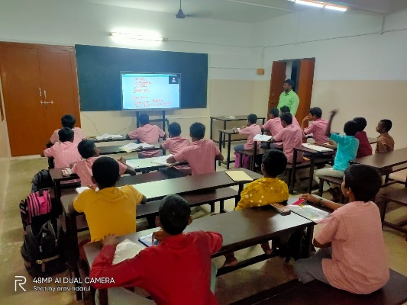

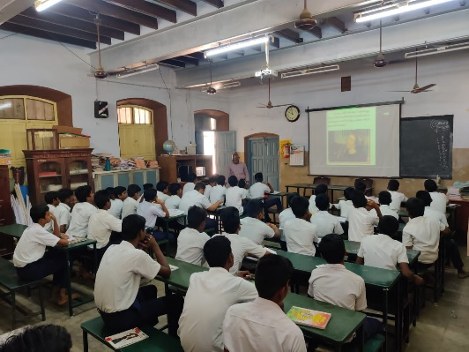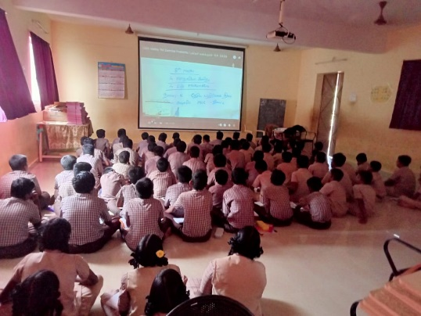

Pravartak Asha Rural Technology Centres

IITM Pravartak Rural Technology Centres (RTCs) aim to spread the knowledge of technology and the benefits that come from it to rural areas of Tamil Nadu. Access to quality technical education is sadly lacking in our villages since personal technical resources are expensive, and there is a dearth of technical skills in these villages to impart knowledge. RTCs aim to address this problem by providing high-quality education in technology for free to middle, high and higher secondary school students.

In addition to offering basic digital literacy and programming courses, the RTCs will offer advanced courses in web development, animation, programming hardware devices through sensors and controllers, etc and also provide the children with a space to experience new technologies with instruction and teacher guidance.

Currently, four are in the Tiruvallur district, and one is in Thoothukudi District. These cater to about 2000 children in various higher secondary schools. We hope to start more in the coming months.

