I-HUB QTF Team Profile

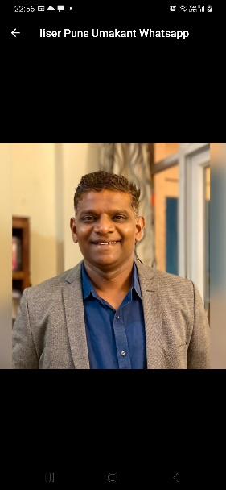 |  | Project Director  (PD)  Prof. Umakant D Rapol
20 yrs+ Industry + Academia Experience: Atomic Physics & Precision Spectroscopy
Research : Quantum Optics, Information Processing, Biosensors
Industry: Design & Development of Optical Sensors & Devices

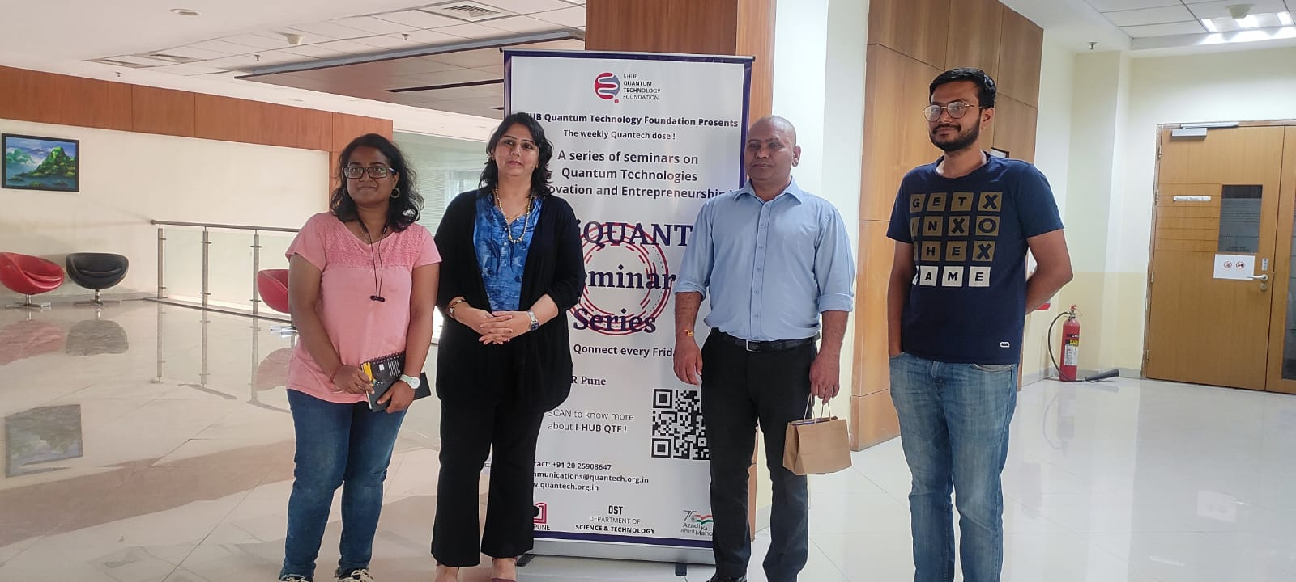 |  | Chief Executive Officer  (CEO)  Dr. Sangeeta Maini K M
20 yrs Industry + Academia Experience: Med Tech | Prototyping | I & E
Research : XRD, Imaging, Simulation, Neuroimaging & Neurospectroscopy
Industry: Product/Prototype Dev. in Adv. Tech.
I & E: Co-working Startup Technology Support, Incubator/Entrepreneurship Program/Project Management, Patenting

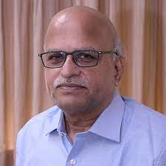 | Chanakya Chair Professor  Prof. S. Ramakrishnan
HUB Quantum Experts:
Elite pool of Theoretical & Experimental Quantum Physicists working on TRL 6+ Projects

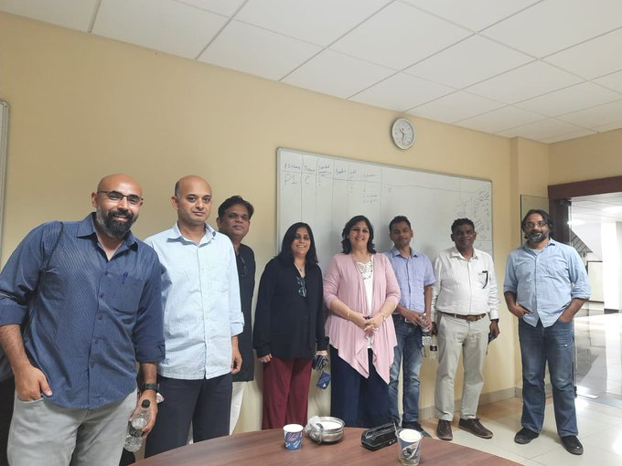
Prof. T. S. Mahesh | Dr. Sunil Nair
Dr. Ashish Arora | Dr. Ashna Bajpai
Prof. M. S. Santhanam | Dr. Rejish Nath
Dr. Surjeet Singh | Dr. G. V. Pavan Kumar
Prof. Umakant D. Rapol | Dr. Bijay Agarwalla
Dr. Atikur Rehman | Dr. Mukul Kabir
Dr. G. J. Sreejith

